Jennings Public School 2223

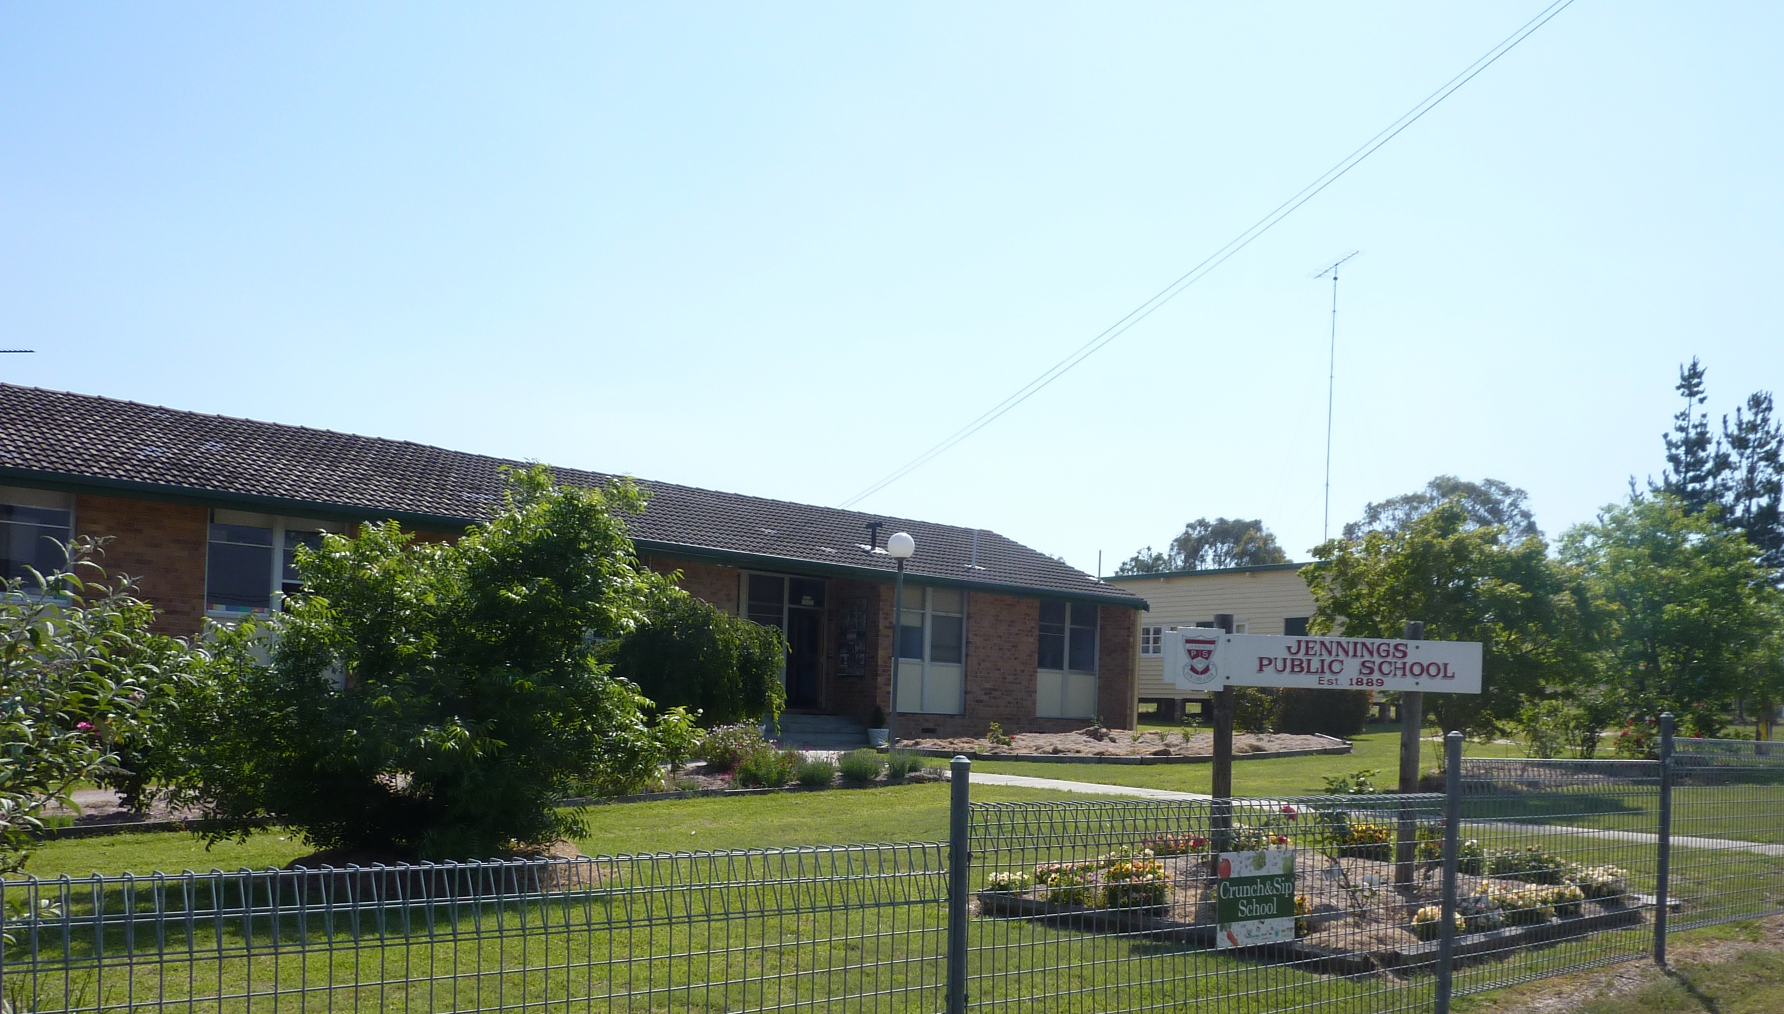

School vision statement |  | School context |  | School planning process
Every student that attends Jennings Public School will have the opportunity to achieve their personal best through engaged, active learning in a safe, respectful and supportive school environment.  This will be achieved through:  - High expectations of both students and staff.  - The delivery of high quality teaching and learning programs which are engaging and relevant to student’s needs and prior learning.  - Increased opportunities for community engagement in the school through extra-curricular activities.  . |  | Jennings Public School is a small PP6 school with 14 students. It is located 18 km north of Tenterfield on the New England Highway on the NSW and QLD border. Jennings Public School is part of the Border Community of Schools, which includes schools in Tenterfield, Mingoola, Deepwater and Bonshaw.  Jennings Public School is involved in the Early Action for Success program which is dedicated to early intervention for students identified as at risk in the early years of schooling. We have one full-time teaching principal and one full-time classroom teacher operating two literacy and numeracy groups K-6. Individual programs are in place to maximise opportunities and improve outcomes for all students.  Jennings Public School is well resourced with a full connected classroom package, an additional interactive whiteboard and video conferencing equipment and laptops and iPads for each student.  The spirit of a small school community fosters individuality allowing input from the students which creates responsibility for their learning and respect of others thus creating an environment of relevance and enjoyment. |  | A variety of formal and informal processes were used to develop the school vision and strategic directions for Jennings Public School.  - Information and consultation evening for parents and community members.  - A survey was sent home to parents asking them identify 3 areas of success, 3 areas of improvement and anything else parents wished to share.  - Informal meetings and discussions with parents at school drop off and pick up.  - Community meetings  - Staff consultation in the form of discussions during staff meetings.  As a result of these consultation processes the following strategic directions were developed:  Student Learning – Students are successful, motivated learners and active and informed community members.  Staff Development – Staff leading innovative practice, learning about what works and connecting with others.

STUDENTS  Students are successful, motivated learners and active and informed community members |  | STAFF  Staff learning about what works, implementing innovative practice and connecting with others
Purpose:  To provide a stimulating learning environment to create students with a high level of understanding and expertise in all areas of learning.  To foster a sense of self-worth and belonging in all students both at school and in the wider community. |  | Purpose:  To develop a culture in which staff members are actively engaged in ongoing learning, strive for improvement and are able to make strong connections beyond the school.

Strategic Direction: Students are successful, motivated learners and active and informed community members

Purpose |  | People |  | Processes |  | Products and Practices
To provide a stimulating learning environment to create students with a high level of understanding and expertise in all areas of learning.  To foster a sense of self-worth and belonging in all students both at school and in the wider community. |  | Students: Levels of achievement in all curriculum areas will be improved through the development of engaging, differentiated teaching and learning designed to meet the needs of all individuals.  Students: K-6 students contributing to the direction of their learning to ensure focused experiences and individualised learning.  Staff: Develop teacher’s deep understanding of student’s strengths and area of needs in order to develop individualised programs.  Staff: Further develop capabilities of teaching staff in the area of differentiated learning.  Parents/Carers: parents/carers are actively engaged partners in their child’s learning.  Community Partners: community will be more engaged in creating a whole school approach to educating the whole child in all areas. |  | Teaching and Learning Programs  - Explicit teaching of literacy and numeracy.  - Curriculum differentiation evident in all lesson plans.  Student Achievement  - Teacher professional development opportunities for best practice. literacy and numeracy programs  - Tier 2 interventions to be provided through the employment of a second classroom teacher and a School Learning Support Officer.  - Tier 3 intervention to be provided for those students not achieving expected benchmarks as part of the Early Action for Success initiative.  Student Wellbeing & Engagement  - Students are actively engaged in the development and monitoring of their own learning goals.  - Students participate in a wide variety of activities both at school and in the wider community to promote a more active and aware citizen.  - Develop positive behaviours through the use of the You Can Do It program.  - School to investigate viability of the purchase of a bus to transport students to events and inter-school days.  Evaluation Plan  Student progression plotted twice a term using literacy and numeracy continuums.  Regularly review data and reflect on areas of need.  Regular parent and community meetings to discuss areas of need and  direction of school |  | - 100% of students showing growth, with 80% achieving at or above stage expected levels on the literacy continuum.  - 100% of students showing growth, with 80% achieving at or above stage expected levels on the numeracy continuum.  Practice:  - All students to be positioned and tracked on the literacy and numeracy continuum.  - Students tracking and monitoring own learning in literacy and mathematics.  - Quality teaching and learning practices across the school, demonstrated through differentiated lessons and assessments to improve student achievement.  - Use of technology to improve literacy and numeracy skills of students – Rainforest Maths, StudyLadder, iPads, ABC Reading Eggs.  - Utilise SENA program to assess student needs and track progress.  - Continue with MultiLit program.  - Implement MiniLit program for Stage 1 students.  - Implement Maths Assessment to monitor student progress in Stage 2 onwards.  - Implement home reading and DEAR program for all students.  Product:  - Further developed literacy and numeracy expertise of current staff.  Practice:  - TEN, CMIT, Counting On strategies are evident in teaching programs and classroom practice.  - L3K strategies are evident in teaching programs and classroom practices.  - Focused comprehension strategies are reflected in teaching programs and evident in classroom practice.  Product:  - Improved engagement in schooling.  - Stronger community relationships.  Practice:  - Link with other small schools for learning days – Drama, Music, Science focus.  - Parents and community members actively involved in the school.  - Students reflecting on the achievement of their personal learning goals.  - Students to participate in CWA international country of study.  - Kitchen garden program reintroduced to school.  - Engagement in hands on activities with community members to boost student’s sense of achievement and community involvement in the school.
Improvement Measures
- 100% of students showing growth, with 80% achieving at or above stage expected levels on the literacy continuum
- 100% of students showing growth, with 80% achieving at or above stage expected levels on the numeracy continuum

Strategic Direction: Staff learning about what works, implementing innovative practice and connecting with others

Purpose |  | People |  | Processes |  | Products and Practices
To develop a culture in which staff members are actively engaged in ongoing learning, strive for improvement and are able to make strong connections beyond the school. |  | Staff: Continue to develop teacher capacity to articulate and deliver effective teaching and learning practices.  Staff: Engage with Tenterfield Community of Schools to build capacity in quality planning, teaching, assessing and reporting.  Staff: Develop teacher capacity to implement the NSW Australian Curriculum  Parents/Carers & Community Partners: collaborate with and provide to parents and community members a clear articulation of the curriculum focus of the school  Leaders: Principals network regularly to support a different mode of operation between schools |  | Professional Learning Framework  - Professional learning is collegial and based around staff identified areas of need  - Develop links with community of schools and other small schools for staff professional development  Teaching and Learning Programs  - Implementation of NSW Australian Curriculum to be a focus of professional learning  - Further develop staff understanding and quality pedagogy in literacy and numeracy to support low performing students  Evaluation Plan  Monitor and review teaching staff professional learning plans in accordance with Professional Development Framework.  Monitor and review SASS professional learning plans.  Teaching and learning programs are developed in line with the NSW Australian curriculum |  | - 100% of staff confidently and successfully teaching with the NSW Australian Curriculum documents  - 100% of staff are actively engaged in the professional development process and have developed and implemented an annual professional learning plan.  Product:  - Professional development for all teaching staff on the content and implementation of NSW Australian curriculum  Practice:  - Teaching and learning programs reflect NSW Australian Curriculum content  - High quality learning experiences based around NSW Australian Curriculum developed  Product:  - Teaching staff involved in instructional rounds  Product:  - Teaching staff trained in literacy and numeracy programs  Practice:  - L3K implemented with Kindergarten students  - TEN pedagogy implemented in both Infants and Primary classroom  - Comprehension strategies program implemented for Primary students  Product:  - A planned program of professional learning that is driven by teacher and school targets.  Practice:  - Staff utilising the Professional Development Framework to create a professional learning plan  - Staff reflect on the achievement of their professional learning goals  - Teachers working towards meeting or maintaining Australian Professional Standards for Teachers.
Improvement Measures
- 100% of staff confidently and successfully teaching with the NSW Australian Curriculum documents
- 100% of staff are actively engaged in the professional development process and are utilising new skills to improve student outcomes.

